EXTRA CREDIT – ADD MONETARY POLICY
Now imagine Fiscal Policy is not feasible for the case you have chosen. Write a paragraph to the President/Leader of the country you are dealing with and explain to him/her how Monetary Policy works and what policy tool you would choose for this particular case. Be sure to include the sequence of events of the tool used. Follow this example:
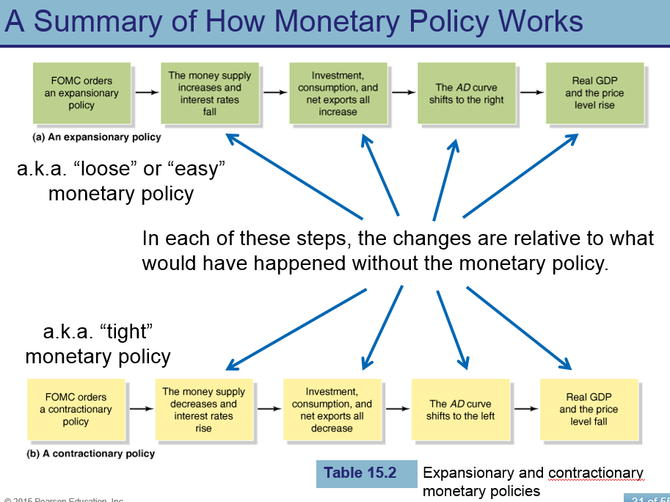
When explaining if expansionary or contractionary policy is being used be as specific as possible, tell the President/Leader if the tool is
- Open-market operations – the buying and selling of government bonds by the Fed.
- The reserve ratio – the fraction of reserves required in banks relative to their customer deposits.
- The discount rate – the interest rate the Fed charges to commercial banks that borrow from the Fed.

